FORWARD CHAINING

AIM: To implement a prolog program for Forward Chaining.

OBJECTIVES:
- To implement forward chaining in Prolog, where new facts are derived from existing facts and rules until the required conclusion is obtained.

ALGORITHM:
- Store initial facts.
- Define rules that derive new facts.
- Start with the known facts.
- Apply rules whose conditions are satisfied.
- Add the newly derived facts.
- Continue until no new facts can be derived.
- Check whether the required conclusion exists.

SYSTEM-ARCHITECTURE:
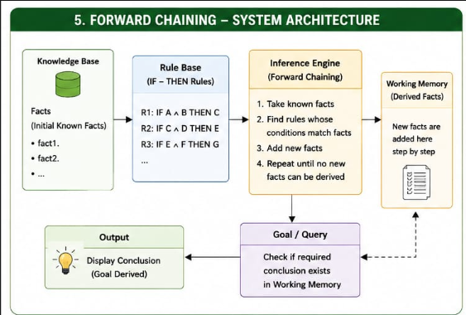

PROGRAM:
% Forward Chaining

fact(sunny).
fact(warm).

rule(happy) :-
fact(sunny),
fact(warm).

rule(go_outside) :-
fact(sunny).

% Forward chaining
forward_chaining :-
derive(happy),
derive(go_outside).

derive(Fact) :-
fact(Fact), !.

derive(Fact) :-
rule(Fact),
assertz(fact(Fact)),
write('Derived: '),
write(Fact),
nl.

OUTPUT:
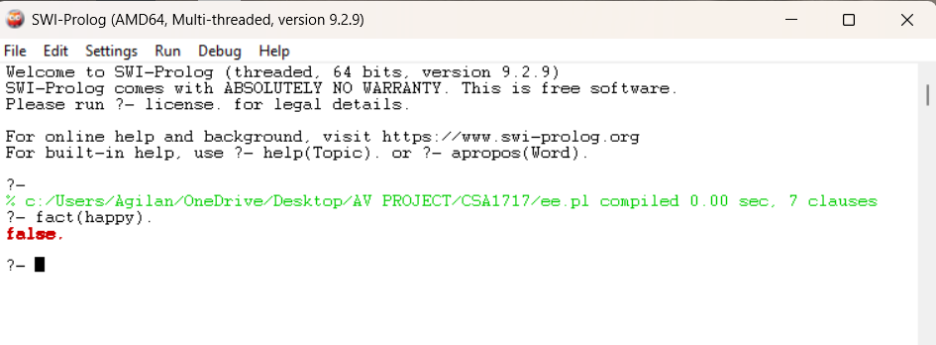

RESULT: Thus the Forward Chaining is implemented successfully using Prolog program.

